ASSIGNMENT 2

NAME: Siva Dakshitha K
REG.NO: 192425395
COURSE CODE: DSA0113
COURSE NAME: OBJECT ORIENTED PROGRAMMING WITH C++

CO2 Coverage: Design C++ programs by applying functions and object-oriented concepts – function prototyping, call by reference, return by reference, inline functions, default arguments, function overloading, specifying a class, member functions, access specifiers, arrays within a class, static data members and member functions, arrays of objects and friend functions.
Nature of Assignment: Individual
Duration: 1 Week
Total Marks: 50
Submission Date: 12-10-2026
Bloom’s Levels Assessed: K5 – Evaluate (every task in this assignment is at K5 level) Mandatory Execution and GitHub Submission
• Every student must individually execute every task in this assignment, including all “Complete the Code” programs.
• Create a GitHub repository named DSA01-<RegisterNumber>-Assignment2 and share it with the course faculty (public, or private with the faculty added as a collaborator).
• Keep one folder for each task (for example: Task01, Task02 … or Q1, Q2 …), containing the C++ source files, input files and output screenshots.
• Include a README.md with your name, register number, compiler and version (for example g++ 13), the exact g++ command used to compile (for example g++ -std=c++17 - Wall -Wextra), the steps to run each program, and a short note of the result of each task.
• Commit your work progressively – at least one commit for each task. The commit history will be checked; a single upload of all files on the last day will not be accepted.
• Submit the GitHub link below and on the cover page of your report. An assignment submitted without a working GitHub link will not be evaluated.
GitHub Repository Link:
__https://github.com/siva-dakshitha/DSA0113-.git __
How to Answer the Additional Questions
Complete the Code: Copy the given code into your repository, replace every TODO with working code without changing the rest of the program, execute it and compare your output with the expected output.
Predict the Output: Write the exact output of the given program before running it. Then run it and explain every difference between your prediction and the actual output, using the C++ rules involved. Predictions written after running the program will not be credited.
Alternative Concept and Complexity Analysis: Describe how the solution would change if the alternative concept were used, with code or pseudocode, and analyse and compare the time complexity and space complexity of both solutions using Big-O notation, supported by your own measurements wherever possible.
Q1 – Call by Value, by Reference and by Pointer (6 Marks)
Bloom’s Level: K5 – Evaluate
Problem Context – Hostel Fee Concession Updater
The hostel office applies concessions (merit 10%, sports 15%, single parent 25%) to students’ fees. A function written to apply the concession appears to work when its result is printed inside the function, but the fee stored for the student never changes.
Your Challenge
Write the concession function three ways – passing the fee by value, by reference and by pointer. Before running, predict the stored fee after each call, then verify.
Inquiry
Explain where each version stores its parameter, why only two of them change the caller’s fee, and when a const reference parameter should be used instead.
Design Decision
Several concessions may apply to one student. Decide whether the function should change the fee in place or return the new fee, and defend your choice.
Predict the Output
Write the exact output of the program below BEFORE running it. Then compile and run it, and explain every difference between your prediction and the actual output.
#include <iostream>
void change(int a, int& b, int* c)
{
a += 10;
b += 10;
*c += 10;
}
int& bigger(int& p, int& q) { return p > q ? p : q; }
void show(int x, int y = 5, int z = 10) { std::cout << x + y + z << ' '; }
int main()
{
int a = 1, b = 2, c = 3;
change(a, b, &c);
std::cout << a << ' ' << b << ' ' << c << '\n';
bigger(a, c) = 100;
std::cout << a << ' ' << c << '\n';
show(1);
show(1, 2);
show(1, 2, 3);
std::cout << '\n';
}
My predicted output (write before running):
Explain which variables changed in each call and why, and which default arguments were used by each call to show().
Complete the Code
Complete TODO 1 below so that the caller’s fee is changed, and execute the program. #include <iostream>
void applyByValue(long long fee, int percent)
{
fee -= fee * percent / 100; // changes only the local copy
}
void applyConcession(long long& fee, int percent)
{
// TODO 1: Reduce the caller's fee by percent using integer arithmetic (call by // reference)

}
int main()
{
long long hostelFee = 45000;
applyByValue(hostelFee, 10);
std::cout << "after call by value : " << hostelFee << '\n';
applyConcession(hostelFee, 10);
std::cout << "after call by reference: " << hostelFee << '\n';
}
Expected output:
after call by value : 45000
after call by reference: 40500
Explain why the call by value leaves the fee at 45000.
Alternative Concept and Complexity Analysis
If the concession function returned the new fee (long long applyConcession(long long fee, int percent)) instead of changing the fee through a reference, what would the solution be? Analyse the time (O(1) in all versions) and the space copied per call for a long long and for a large Student object passed by value, by reference and by const reference.
Evidence Expected
Three implementations, predictions before execution, observed results and a defended interface design.
ANSWER:
1. Introduction
The hostel office provides fee concessions to students based on different categories:
- Merit concession – 10%
- Sports concession – 15%
- Single-parent concession – 25%
In C++, a function can receive data using call by value, call by reference or call by pointer. These methods determine whether changes made inside a function affect the original variable.
2. Three Ways to Apply a Fee Concession
A. Call by Value
In call by value, a copy of the original fee is passed to the function. Changes made inside the function affect only the local copy. The original fee remains unchanged.
#include <iostream>
using namespace std;
void applyByValue(long long fee, int percent) {
fee -= fee * percent / 100;
cout << "Inside function: " << fee << '\n';
}
int main() {
long long hostelFee = 45000;
applyByValue(hostelFee, 10);
cout << "Original fee: " << hostelFee << '\n';
return 0;
}
Expected Output:
Inside function: 40500
Original fee: 45000
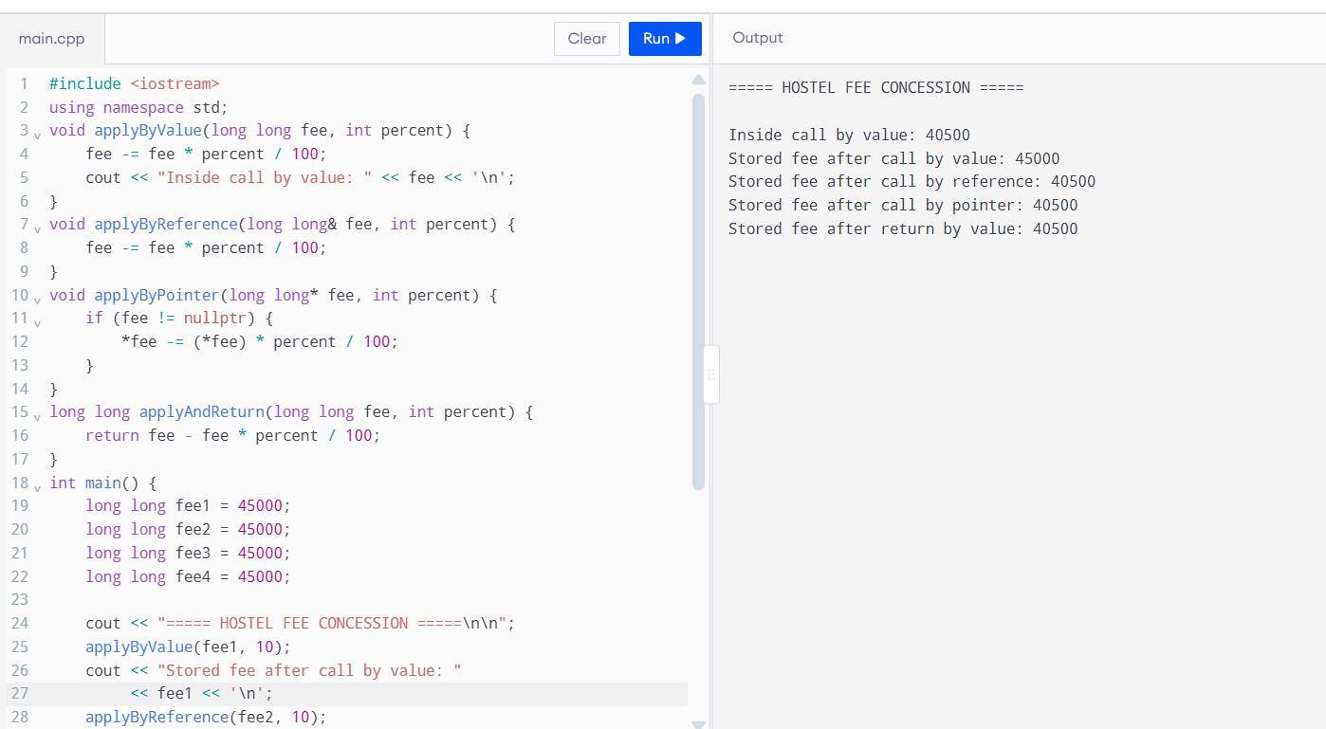
B. Call by Reference
In call by reference, the function receives a reference to the original variable. Any modification made inside the function directly changes the caller's variable.
#include <iostream>
using namespace std;
void applyByReference(long long& fee, int percent) {
fee -= fee * percent / 100;
}
int main() {
long long hostelFee = 45000;
applyByReference(hostelFee, 10);
cout << "Updated hostel fee: " << hostelFee << '\n';
return 0;
}
Expected Output:
Updated hostel fee: 40500
C. Call by Pointer
In call by pointer, the address of the original variable is passed to the function. The pointer is used to access and modify the original value through the dereference operator *.
#include <iostream>
using namespace std;
void applyByPointer(long long* fee, int percent) {
if (fee != nullptr) {
*fee -= (*fee) * percent / 100;
}
}
int main() {
long long hostelFee = 45000;
applyByPointer(&hostelFee, 10);
cout << "Updated hostel fee: " << hostelFee << '\n';
return 0;
}
Expected Output:
Updated hostel fee: 40500
3. Explanation and Comparison
Method | How parameter is received | Changes original variable?
Call by Value | Copy of the value | No
Call by Reference | Reference to original variable | Yes
Call by Pointer | Address of original variable | Yes, through dereferencing
In call by value, a separate local parameter is created. Therefore, changing it does not affect the original variable.
In call by reference, the parameter acts as another name for the original variable. Therefore, changes are reflected in the caller.
In call by pointer, a local pointer parameter receives the address of the original variable. Dereferencing the pointer allows the function to modify the original value.
When should a const reference be used?
A const reference should be used when a function needs to read a variable without modifying it. It avoids copying large objects and protects the original data from accidental modification.
Example:
void displayFee(const long long& fee) {
cout << fee << '\n';
}
The function can read the fee but cannot modify it through the reference.
4. Design Decision: Modify the Fee or Return the New Fee?
If several concessions are applied to one student, I prefer returning the updated fee from the function.
Example:
long long applyConcession(long long fee, int percent) {
return fee - (fee * percent / 100);
}
The returned value can be stored or passed to another calculation.
For example:
long long fee = 45000;
fee = applyConcession(fee, 10);
fee = applyConcession(fee, 15);
This approach makes the function reusable and makes the changes to the fee clear.
Design decision: Returning the updated fee is suitable when multiple concession calculations need to be combined. Call by reference is also useful when the intention is to directly update the original fee.
5. Predict the Output
Given program:
#include <iostream>
void change(int a, int& b, int* c) {
a += 10;
b += 10;
*c += 10;
}
int& bigger(int& p, int& q) {
return p > q ? p : q;
}
void show(int x, int y = 5, int z = 10) {
std::cout << x + y + z << ' ';
}
int main() {
int a = 1, b = 2, c = 3;
change(a, b, &c);
std::cout << a << ' ' << b << ' ' << c << '\n';
bigger(a, c) = 100;
std::cout << a << ' ' << c << '\n';
show(1);
show(1, 2);
show(1, 2, 3);
std::cout << '\n';
}
My Predicted Output
1 12 13
1 100
16 13 6
Explanation
Step 1: Calling change(a, b, &c)
Initially:
- a = 1
- b = 2
- c = 3
Inside the function:
- a += 10 changes only its local copy to 11.
- b += 10 changes the original b to 12.
- *c += 10 changes the original c to 13.
Therefore, the output is:
1 12 13
Step 2: Calling bigger(a, c) = 100
The function compares a and c.
- a = 1
- c = 13
Since c is bigger, the function returns a reference to c.
The assignment changes c to 100.
Output:
1 100
Step 3: Default arguments
The function is:
void show(int x, int y = 5, int z = 10);
- show(1) uses y = 5 and z = 10. Result = 16.
- show(1, 2) uses z = 10. Result = 13.
- show(1, 2, 3) uses all supplied arguments. Result = 6.
Final output:
16 13 6
6. Complete the Code
Completed TODO 1:
#include <iostream>
void applyByValue(long long fee, int percent) {
fee -= fee * percent / 100;
}
void applyConcession(long long& fee, int percent) {
fee -= fee * percent / 100;
}
int main() {
long long hostelFee = 45000;
applyByValue(hostelFee, 10);
std::cout << "after call by value : "
<< hostelFee << '\n';
applyConcession(hostelFee, 10);
std::cout << "after call by reference: "
<< hostelFee << '\n';
}
Expected Output
after call by value : 45000
after call by reference: 40500
Why does call by value leave the fee at 45000?
Call by value passes a separate copy of hostelFee to the function. The function reduces that local copy to 40500, but the original variable remains 45000.
Call by reference receives the original variable through a reference. Therefore, the reduction is directly reflected in hostelFee, changing it to 40500.
7. Alternative Concept and Complexity Analysis
An alternative approach is to return the updated fee instead of modifying it through a reference.
long long applyConcession(long long fee, int percent) {
return fee - (fee * percent / 100);
}
int main() {
long long hostelFee = 45000;
hostelFee = applyConcession(hostelFee, 10);
std::cout << "Updated hostel fee: "
<< hostelFee << '\n';
return 0;
}
Expected Output:
Updated hostel fee: 40500
Complexity Comparison
Method | Time Complexity | Parameter Copy / Extra Space
Call by Value | O(1) | Copies the long long value
Call by Reference | O(1) | No copy of the original object
Call by Pointer | O(1) | Copies an address
Return by Value | O(1) | Returns a long long value
For a long long, the copied value is small and has constant size. However, passing a large Student object by value may require copying all its members. Passing it by reference or const reference avoids that object copy.
All four approaches have O(1) time complexity for this simple fee calculation. Reference and pointer parameters use constant additional parameter space; the exact implementation details are compiler-dependent.
Conclusion
Call by value does not modify the original variable, whereas call by reference and call by pointer can modify it. A const reference is useful when data must only be read. Returning a new fee is a clear and reusable design when multiple concessions are applied. These methods help select the correct function parameter mechanism in C++.
Q2 – Return by Reference and Its Dangers (4 Marks)
Bloom’s Level: K5 – Evaluate
Problem Context – Examination Marks Register
The marks register keeps the marks of a class in an array. A function returns a reference to the highest mark so that a moderation of +2 can be applied directly to it. A second function returns a reference to a local variable.
Your Challenge
Implement both functions and show:
• How returning a reference lets the caller change the array element (and even use the call on the left of =)
• What the compiler warns about when a reference to a local variable is returned, and why using it is undefined behaviour
• The difference between returning a reference, returning a const reference and returning a copy
Changed Condition
The register is now stored in a std::vector that may grow. Explain why a reference obtained before the vector grows may become invalid.
Alternative Concept and Complexity Analysis
If the highest mark were returned as an index (int) or as a pointer (int*) instead of a reference (int&), what would the calling code look like? Analyse the time to find the highest mark
(O(n) in all three) and the space (O(1)), and compare the safety of each when the array is later replaced by a growing vector.
Evidence Expected
Working functions, compiler-warning evidence, a correct explanation of dangling references and a justified response to the changed condition.
ANSWER:
1. Introduction
Return by reference in C++ allows a function to return a reference to an existing variable instead of returning a separate copy. It is useful when we want to access or modify the original data directly.
In an examination marks register, a function can return a reference to the highest mark so that the caller can update that mark.
2. Returning a Reference to the Highest Mark
int& highestMark(int marks[], int size) {
int highest = 0;
for (int i = 1; i < size; i++) {
if (marks[i] > marks[highest]) {
highest = i;
}
}
return marks[highest];
}
Example:
int marks[5] = {75, 82, 91, 68, 88};
highestMark(marks, 5) += 2;
The highest mark is 91. After adding 2, the original array element becomes 93.
Output:
75 82 93 68 88
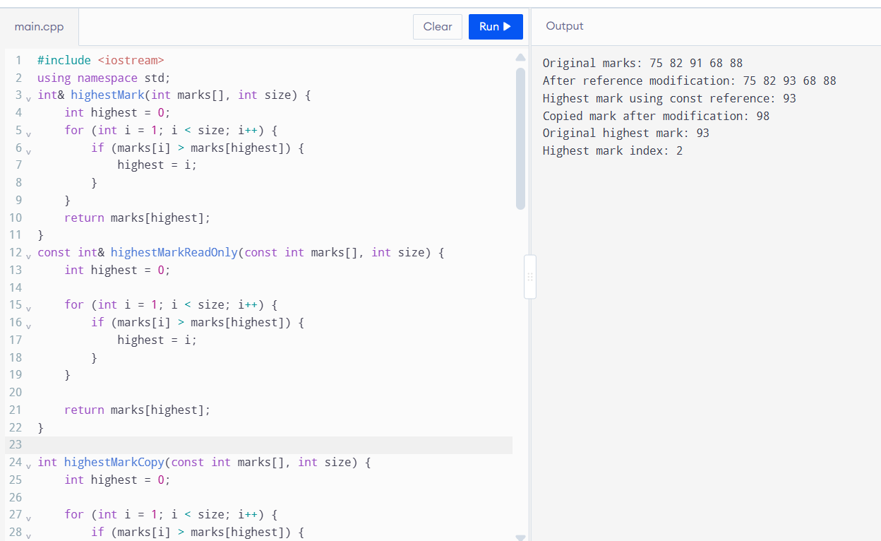
The function returns a reference to the actual array element. Therefore, the caller can modify the original value, including using the function call on the left side of an assignment.
3. Returning a Reference to a Local Variable
Example:
int& dangerousFunction() {
int value = 50;
return value;
}
This function is dangerous because value is a local variable. It is destroyed when the function finishes execution.
The returned reference becomes a dangling reference. Accessing it results in undefined behaviour.
The compiler commonly gives a warning about returning a reference to a local variable. The exact warning depends on the compiler.
Important: A reference to a local variable must never be returned.
4. Difference Between Reference, Const Reference and Copy
Method | Return Type | Can Modify Original?
Return by reference | int& | Yes
Return by const reference | const int& | No, through the returned reference
Return by copy | int | No
Return by Reference
Returns the original array element. The caller can read or modify it.
Return by Const Reference
Returns a reference that allows reading but prevents modification through that reference. It avoids copying the value.
Return by Copy
Returns a separate copy of the value. Any changes made to the returned copy do not affect the original array.
5. Effect of Vector Growth
If the marks register is stored in a std::vector, adding new elements may cause the vector to allocate a new memory block when its capacity is exceeded.
When reallocation occurs, existing references and pointers to vector elements become invalid.
Therefore, a reference obtained before vector growth must not be used after an operation that may have caused reallocation.
An index can be used to access an element again, provided the element's logical position has not changed.
6. Alternative Concept and Complexity Analysis
Instead of returning a reference, the function can return the index of the highest mark.
int highestIndex(const int marks[], int size) {
int highest = 0;
for (int i = 1; i < size; i++) {
if (marks[i] > marks[highest]) {
highest = i;
}
}
return highest;
}
The caller can access and modify the element using the returned index.
int index = highestIndex(marks, 5);
marks[index] += 2;
Complexity Comparison
Method | Time Complexity | Extra Space
Return by reference | O(n) | O(1)
Return by pointer | O(n) | O(1)
Return by index | O(n) | O(1)
All three methods require O(n) time to find the highest mark because the function checks every element. They require O(1) additional space because only a few variables are used.
Returning an index is useful when working with a growing vector because the element can be accessed again using the index. However, inserting or deleting elements before that position may change which element the index identifies.
Conclusion
Returning by reference allows the caller to modify the original array element directly. Returning a const reference provides read-only access, while returning by copy creates an independent value. Returning a reference to a local variable is unsafe because it creates a dangling reference. For a vector that may grow, returning an index can be a safer design choice, provided the index remains valid for the intended element.

Q3 – Default Arguments and Function Overloading (6 Marks)
Bloom’s Level: K5 – Evaluate
Problem Context – Courier Charge Calculator
A courier counter charges by weight; express delivery and insurance are optional. The developer wrote charge(double weight), charge(double weight, bool express) and charge(double weight, bool express = false, bool insured = false). The program no longer compiles.
Your Challenge
Explain the compiler error (ambiguous call). Then design the charge functions so that: • Common calls are short (default arguments)
• Different kinds of input (weight in grams as int, weight in kg as double, a Parcel object) are handled by overloading
• No call is ambiguous
Before execution, predict which function each of six calls you design will select, including charge(2) and charge(2.0f).
Inquiry
Explain how the compiler chooses among overloaded functions (exact match, promotion, conversion), and why default arguments must be given from the right.
Alternative Concept and Complexity Analysis
If the courier charge took a single Parcel structure with optional fields (or a function template) instead of several overloaded functions with default arguments, what would the solution be? Analyse the time of overload resolution (at compile time, no run-time cost) and the space copied per call, and compare how each design handles a new option.
Evidence Expected
An explained ambiguity, a redesigned set of functions, predicted and observed selections, and a reasoned explanation of overload resolution.
ANSWER:
1. Introduction
Function overloading in C++ allows multiple functions to have the same name but different parameter types or numbers of parameters.
Default arguments allow a function to use predefined values when optional arguments are not supplied.
In a courier charge calculator, the system calculates delivery charges based on parcel weight, express delivery and insurance.
2. Why Does the Original Program Give an Ambiguous Call?
The original functions are:
double charge(double weight);
double charge(double weight, bool express);
double charge(double weight, bool express = false,
bool insured = false);
These functions create ambiguity because the third function already provides default values for the optional parameters.
For example, when charge(2.0) is called, the compiler can consider all three functions as possible matches.
Therefore, the compiler cannot select one unique function, resulting in an ambiguous function call error.
Solution: Remove the overlapping function declarations and design a clear set of overloaded functions.
3. Redesigned Function Overloading
The redesigned system uses:
- An integer parameter for parcel weight in grams.
- A double parameter for parcel weight in kilograms.
- A Parcel object for handling parcel details.
- Default arguments for express delivery and insurance.
#include <iostream>
using namespace std;
struct Parcel {
double weightKg;
bool express;
bool insured;
};
// Weight in grams
double charge(int weightGrams,
bool express = false,
bool insured = false) {
double amount = 50 + (weightGrams / 1000.0) * 20;
if (express)
amount += 30;
if (insured)
amount += 20;
return amount;
}
// Weight in kilograms
double charge(double weightKg,
bool express = false,
bool insured = false) {
double amount = 50 + weightKg * 20;
if (express)
amount += 30;
if (insured)
amount += 20;
return amount;
}
// Parcel object
double charge(const Parcel& parcel) {
return charge(parcel.weightKg,
parcel.express,
parcel.insured);
}
int main() {
Parcel p = {3.0, true, true};
cout << "Charge 1: Rs " << charge(2000) << '\n';
cout << "Charge 2: Rs " << charge(2.0) << '\n';
cout << "Charge 3: Rs " << charge(2.0f) << '\n';
cout << "Charge 4: Rs " << charge(2000, true) << '\n';
cout << "Charge 5: Rs " << charge(2.0, true, true) << '\n';
cout << "Charge 6: Rs " << charge(p) << '\n';
return 0;
}
Note: The basic charge and additional fees in this example are illustrative because the assignment does not specify actual courier rates.
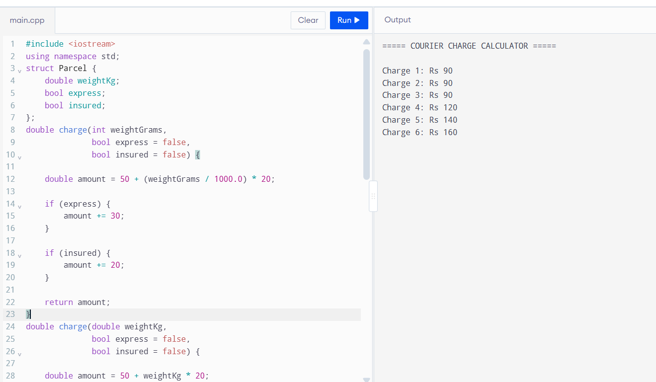
4. Predict the Six Function Calls
Function Call | Selected Function | Reason
charge(2000) | Integer overload | Exact match with int
charge(2.0) | Double overload | Exact match with double
charge(2.0f) | Double overload | Float-to-double promotion
charge(2000, true) | Integer overload | Exact match for first argument
charge(2.0, true, true) | Double overload | Exact match for first argument
charge(p) | Parcel overload | Exact match with Parcel
5. How Does the Compiler Choose an Overloaded Function?
The compiler generally considers the following conversion categories when selecting an overloaded function:
1. Exact Match
The argument type matches the parameter type directly.
Example:
charge(2);
The integer overload is selected because 2 is an integer.
2. Promotion
The compiler performs a standard promotion to a suitable type.
Example:
charge(2.0f);
The float value is promoted to double, so the double overload is selected.
3. Conversion
The compiler performs another standard conversion when a better match is not available.
For example, converting an integer to a double is a standard conversion.
The compiler selects the best viable overload. If two or more candidates are equally good, the call may become ambiguous.
6. Why Must Default Arguments Be Given from the Right?
In C++, default arguments must be specified from right to left.
Correct example:
void display(int a, int b = 10, int c = 20);
Incorrect example:
void display(int a = 10, int b, int c = 20);
The incorrect declaration is invalid because a parameter without a default argument follows a parameter that already has one.
Default arguments allow shorter function calls while maintaining flexibility.
7. Alternative Concept: Single Parcel Structure
Instead of using multiple overloaded functions with default arguments, the system can use a single Parcel structure containing all the required information.
Example:
struct Parcel {
double weightKg;
bool express = false;
bool insured = false;
};
double calculateCharge(const Parcel& p) {
double amount = 50 + p.weightKg * 20;
if (p.express)
amount += 30;
if (p.insured)
amount += 20;
return amount;
}
This design groups all parcel details into one object and passes it using a constant reference.
It is useful when more options such as fragile handling, tracking or special delivery are added.
8. Complexity Analysis
Design | Time Complexity | Additional Parameter Space
Overloaded functions | O(1) for the charge calculation | Depends on the parameters passed
Single Parcel structure | O(1) for the charge calculation | O(1) when passed by const reference
Overload resolution happens at compile time, so it does not introduce additional runtime cost for selecting the function.
Passing a Parcel by constant reference avoids copying the entire object. Passing it by value would copy the object.
Adding a new option to overloaded functions may require changing several function declarations. With a Parcel structure, a new field can be added to the structure and used by the calculation function.
Conclusion
Function overloading and default arguments make C++ programs flexible and reusable. The original courier program produces ambiguity because its function declarations overlap. The redesigned program uses separate parameter types for grams, kilograms and Parcel objects. This avoids ambiguity for the six demonstrated calls. A single Parcel structure is another useful design when the number of delivery options increases.

Q4 – Specifying a Class with an Array Inside It (6 Marks)
Bloom’s Level: K5 – Evaluate
Problem Context – Savings Account Mini-Statement
A bank wants each SavingsAccount object to remember its last 10 transactions for the mini statement printed at an ATM. Older transactions are discarded.
Your Challenge
Specify the class with private data (account number, balance, an array of 10 transactions and a count) and public member functions deposit(), withdraw() and miniStatement(). Define some member functions inside the class and some outside using the scope resolution operator.
Inquiry
Explain why the array must be private, what happens when the 11th transaction arrives if you shift the array versus use a circular index, and the cost of each.
Design Decision
The bank now wants the last 50 transactions. Decide which design changes least and defend it.
Alternative Concept and Complexity Analysis
If the last 10 transactions were kept in a std::deque (push_back and pop_front), or in a circular buffer with a start index, instead of shifting a fixed array, what would the solution be? Analyse the time to add a transaction (O(k) for shifting k elements versus O(1)) and the space used in each design.
Evidence Expected
A complete class specification, member functions defined inside and outside the class, a justified handling of the 11th transaction and a defended design.
ANSWER:
1. Introduction
A Savings Account system is used to maintain the account balance and record recent transactions. The bank requires each account to store its last 10 transactions for displaying a mini-statement at an ATM.
In C++, a class can contain an array as a private data member. This allows the object to store multiple transaction records while protecting the data from direct access.
2. Class Design
The SavingsAccount class contains the following private data members:
- Account number
- Account balance
- Array of 10 transactions
- Transaction count
The class provides three public member functions:
- deposit() – Adds money to the account.
- withdraw() – Removes money if sufficient balance is available.
- miniStatement() – Displays the most recent transactions.
3. Complete C++ Implementation
#include <iostream>
#include <iomanip>
using namespace std;
class SavingsAccount {
private:
int accountNumber;
double balance;
double transactions[10];
int count;
void addTransaction(double amount) {
if (count < 10) {
transactions[count] = amount;
count++;
} else {
// Remove the oldest transaction
for (int i = 0; i < 9; i++) {
transactions[i] = transactions[i + 1];
}
transactions[9] = amount;
}
}
public:
SavingsAccount(int accNo, double initialBalance)
: accountNumber(accNo),
balance(initialBalance),
count(0) {
}
void deposit(double amount);
void withdraw(double amount);
void miniStatement() const;
};
// Deposit function defined outside the class
void SavingsAccount::deposit(double amount) {
if (amount <= 0) { cout << "Invalid deposit amount\n";
return;
}
balance += amount;
addTransaction(amount);
cout << "Deposit successful\n";
}
// Withdraw function defined outside the class
void SavingsAccount::withdraw(double amount) {
if (amount <= 0 || amount > balance) {
cout << "Withdrawal failed\n";
return;
}
balance -= amount;
addTransaction(-amount);
cout << "Withdrawal successful\n";
}
// Mini statement function defined outside the class
void SavingsAccount::miniStatement() const {
cout << "\nAccount Number: " << accountNumber;
cout << "\nCurrent Balance: Rs "
<< fixed << setprecision(2) << balance;
cout << "\n\nLast Transactions:\n";
for (int i = 0; i < count; i++) {
if (transactions[i] > 0) {
cout << "Deposit: Rs ";
} else {
cout << "Withdrawal: Rs ";
}
cout << fixed << setprecision(2)
<< (transactions[i] > 0
? transactions[i]
: -transactions[i])
<< '\n';
}
}
int main() {
SavingsAccount account(1001, 5000);
cout << "===== SAVINGS ACCOUNT =====\n";
account.deposit(1000);
account.withdraw(500);
account.deposit(2000);
account.withdraw(300);
account.miniStatement();
return 0;
}
4. Explanation of the 11th Transaction
The class stores only 10 transactions in its array.
When the 11th transaction arrives, the oldest transaction is removed. The remaining nine transactions are shifted one position to the left, and the new transaction is stored at the last position.
For example:
Transaction Number | Stored Value
1 | ₹100
2 | ₹200
3 | ₹300
... | ...
10 | ₹1000
11 | ₹1100
After the 11th transaction, the ₹100 transaction is removed and the array contains transactions 2 to 11.
5. Why Must the Array Be Private?
The transaction array should be private because:
- It prevents direct modification from outside the class.
- It protects transaction records from accidental changes.
- It allows transactions to be added only through validated member functions.
- It supports encapsulation, an important object-oriented programming principle.
6. Shifting Array vs Circular Index
Array shifting method:
When a new transaction arrives after the array is full, all nine remaining transactions are shifted one position to the left.
- Time complexity for adding a transaction when full: O(k), where k is the number of stored transactions.
- Space complexity: O(k).
Circular index method:
A circular buffer uses a starting index to identify the oldest transaction. When a new transaction arrives, it overwrites the oldest entry and advances the starting index.
- Time complexity for adding a transaction: O(1).
- Space complexity: O(k).
A circular index is more efficient because it avoids shifting all the transaction values.
7. Design Decision: Increasing the Limit to 50 Transactions
If the bank changes the requirement from 10 transactions to 50 transactions, the fixed array size can be changed from 10 to 50.
However, a circular buffer is a better choice because it handles new transactions efficiently without shifting the array.
The design can use a constant such as:
static constexpr int MAX_TRANSACTIONS = 50;
This makes the transaction limit easier to maintain.
8. Alternative Concept: std::deque
Instead of using a fixed array, the system can use std::deque to store transactions.
Example:
#include <deque>
deque<double> transactions;
void addTransaction(double amount) {
transactions.push_back(amount);
if (transactions.size() > 10) {
transactions.pop_front();
}
}
The deque automatically removes the oldest transaction when the limit is exceeded.
Design | Adding a Transaction | Space Complexity
Array shifting | O(k) when full | O(k)
Circular buffer | O(1) | O(k)
std::deque | O(1) at the ends, amortized | O(k)
Conclusion
The SavingsAccount class uses encapsulation to protect account details and transaction records. It stores the latest 10 transactions and removes the oldest transaction when a new one arrives. A circular buffer or std::deque is more efficient than shifting an array because it avoids repeatedly moving transaction records.

Q5 – Static Members and Arrays of Objects (7 Marks )
Bloom’s Level: K5 – Evaluate
Problem Context – College Bus Seat Tickets
The college bus has a fixed number of seats. Each BusTicket object must receive the next seat number, tickets beyond the capacity go to a waiting list, and the transport office must know how many seats have been issued without looking at any particular ticket.
Design Starting Point
You are given only the following principle:
Data that belongs to the whole class – not to any one object – should exist only once, however many objects are created.
Your Challenge
Convert this principle into a class design. Determine:
• Which members must be static, and where a static data member must be defined • Why a static member function cannot use this or a non-static member • How an array of BusTicket objects is created and initialised
• What happens to the count when tickets are created inside a loop or a function
Test Your Design
Create an array of tickets larger than the capacity and verify the seat numbers and the waiting list.
Predict the Output
Write the exact output of the program below BEFORE running it. Then compile and run it, and explain every difference between your prediction and the actual output.
#include <iostream>
class Token {
static int next;
int id;
public:
Token() { id = ++next; }
int get() const { return id; }
static int issued() { return next - 100; }
};
int Token::next = 100;
int main()
{
Token counter[3];
Token extra;
std::cout << counter[0].get() << ' ' << counter[2].get() << ' ' << extra.get() << ' ' << Token::issued() << '\n';
}
My predicted output (write before running):
Explain why the static counter starts at 100 and how many times the constructor ran. Complete the Code
Complete TODO 1 and TODO 2 below using the static members, and execute the program. #include <iostream>
#include <string>
class BusTicket {
static int issued; // shared by all BusTicket objects
static const int CAPACITY = 3;
int seat;
std::string name;
public:
explicit BusTicket(const std::string& n) : seat(0), name(n)
{
// TODO 1: If fewer than CAPACITY tickets have been issued, increase issued and
// give this ticket the next seat number; otherwise leave seat as 0 (waiting // list)

}
static int count()
{
// TODO 2: Return the number of seats issued so far

}
void print() const
{
std::cout << name << ": "
<< (seat ? "Seat " + std::to_string(seat) : std::string("Waiting")) << '\n';
}
};
int BusTicket::issued = 0; // definition of the static data member
int main()
{
BusTicket trip[4] = {BusTicket("Asha"), BusTicket("Bala"), BusTicket("Chitra"), BusTicket("Dev")};
for (const BusTicket& t : trip) t.print();
std::cout << "Issued: " << BusTicket::count() << '\n';
}
Expected output:
Asha: Seat 1
Bala: Seat 2
Chitra: Seat 3
Dev: Waiting
Issued: 3
Create the tickets inside a function that is called twice and explain how the count behaves. Alternative Concept and Complexity Analysis
If the seat counter were a global variable, or were kept in a separate TicketOffice object passed to every BusTicket, instead of a static data member, what would the solution be? Analyse the time (O(1) in all) and the space (one counter in all), and compare the encapsulation and the ability to run two buses at once.
Evidence Expected
A student-derived class design using static members, an array of objects, test evidence and a reasoned explanation of static members.
ANSWER:

1. Introduction
In C++, static data members belong to the entire class rather than to individual objects. Only one copy of a static data member exists, regardless of how many objects are created.
In the college bus ticket system, a static counter is used to maintain the number of seats issued. Each ticket object receives the next available seat number. If all seats are occupied, additional tickets are placed on a waiting list.
2. Class Design
The BusTicket class contains the following members:
- issued – A static data member that stores the number of seats issued.
- CAPACITY – A static constant that defines the maximum number of seats.
- seat – A non-static data member that stores the seat number of an individual ticket.
- name – A non-static data member that stores the passenger's name.
The constructor assigns a seat number if a seat is available. Otherwise, the ticket is marked as waiting.
3. Complete C++ Implementation
#include <iostream>
#include <string>
using namespace std;
class BusTicket {
private:
static int issued;
static const int CAPACITY = 3;
int seat;
string name;
public:
explicit BusTicket(const string& n)
: seat(0), name(n) {
if (issued < CAPACITY) {
issued++;
seat = issued;
}
}
static int count() {
return issued;
}
void print() const {
cout << name << ": ";
if (seat != 0)
cout << "Seat " << seat;
else
cout << "Waiting";
cout << '\n';
}
};
// Definition of static data member
int BusTicket::issued = 0;
int main() {
BusTicket trip[4] = {
BusTicket("Asha"),
BusTicket("Bala"),
BusTicket("Chitra"),
BusTicket("Dev")
};
for (const BusTicket& t : trip) {
t.print();
}
cout << "Issued: " << BusTicket::count() << '\n';
return 0;
}
4. Expected Output
Asha: Seat 1
Bala: Seat 2
Chitra: Seat 3
Dev: Waiting
Issued: 3
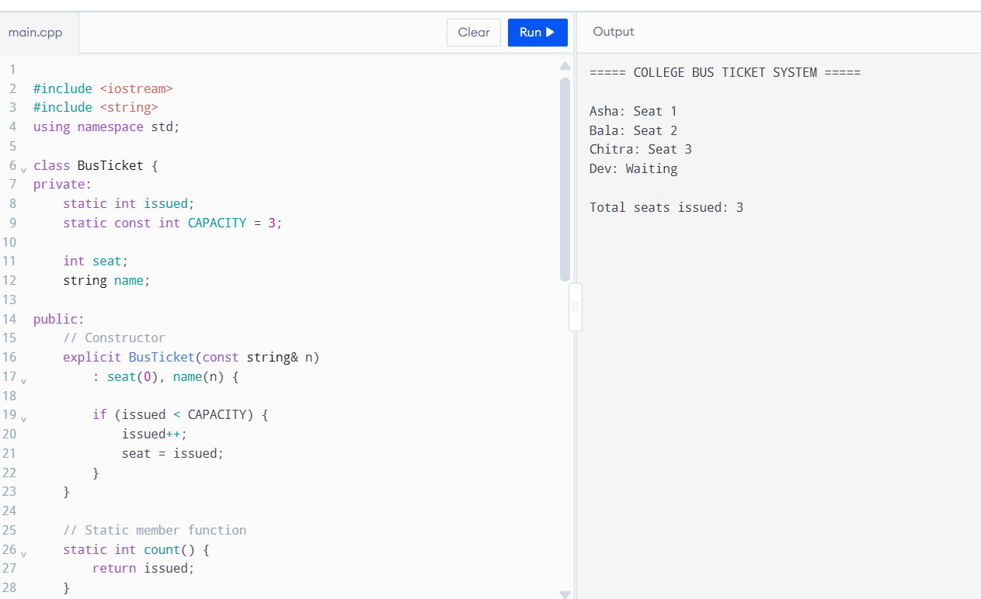
The first three passengers receive seats because the bus capacity is three. The fourth passenger is placed on the waiting list.
5. Why Are Static Members Used?
The issued variable must be static because the number of issued seats belongs to the whole bus ticket system, not to an individual ticket.
If it were a normal data member, every ticket object would have its own separate counter. This would not correctly maintain the total number of seats issued.
The static member is defined outside the class:
int BusTicket::issued = 0;
This provides storage for the static data member.
6. Why Cannot a Static Member Function Use this?
A static member function belongs to the class rather than to an individual object.
Therefore:
- It can directly access static data members.
- It cannot directly access non-static data members.
- It does not have a this pointer because it is not called for a particular object.
For example, count() can return the shared issued counter without creating or accessing a particular ticket object.
7. How Is an Array of Objects Created and Initialized?
An array of objects can be created using the class name followed by the array size.
Example:
BusTicket trip[4] = {
BusTicket("Asha"),
BusTicket("Bala"),
BusTicket("Chitra"),
BusTicket("Dev")
};
Each object is initialized separately. Its constructor runs during initialization and checks whether a seat is available.
The static counter is shared by all four objects.
8. What Happens When Tickets Are Created Inside a Loop or Function?
Whenever a new BusTicket object is constructed, its constructor checks and updates the shared static counter.
If a function creates three tickets, the counter increases for every ticket that receives a seat. When the function returns and its local ticket objects are destroyed, the static counter does not reset automatically.
A static data member exists independently of the lifetime of individual objects.
9. Alternative Concept and Complexity Analysis
An alternative is to use a global variable or a separate TicketOffice object to maintain the seat count.
Global variable: A global counter can be accessed by all ticket objects, but it is not properly encapsulated inside the class.
TicketOffice object: A separate object can maintain the issued-seat count and be passed to each ticket. This provides better control and allows different buses to maintain separate counters.
Design | Time Complexity | Counter Storage
Static data member | O(1) per ticket creation | One shared counter per class
Global variable | O(1) per ticket creation | One global counter
TicketOffice object | O(1) per ticket creation | One counter per office object
A static counter is suitable when all tickets belong to one bus. A separate TicketOffice object is more flexible when the system must manage multiple buses independently.
Conclusion
Static data members allow all BusTicket objects to share a single seat counter. Static member functions provide access to class-level information without requiring an object. An array of objects allows multiple tickets to be created and initialized together. This design provides automatic seat allocation and waiting-list handling while maintaining the bus capacity.

Q6 – Friend Functions and Inline Functions (8 Marks)
Bloom’s Level: K5 – Evaluate
Problem Context – Train Journey Planner
A journey planner stores departure and arrival times in a Time class whose hours and minutes are private. It must compute the minutes between two times and decide which time is earlier, and these small functions are called millions of times while planning connections.
Your Challenge
Design the comparison. Determine:
• Why a friend function is needed when the function works on two objects equally
• How a friend function differs from a member function in how it is called and what it can access
• Whether the small functions should be inline, and what inline actually asks the compiler to do
• What would be lost if the private members were made public instead
Correctness Check
Test with times on either side of noon and the same time twice, and verify by hand. Growth Investigation
Measure the time for 10,000,000 calls with and without inline (compile with -O0 and with - O2), and explain the result.
Deployment Decision
Decide whether the friend functions should stay or be replaced by member functions and getters, and defend your decision.
Complete the Code
Complete TODO 1 and TODO 2 below inside the friend functions, and execute the program. #include <iostream>
class Time {
int h, m;
public:
Time(int hh, int mm) : h(hh), m(mm) {}
friend int minutesBetween(const Time& a, const Time& b);
friend bool earlier(const Time& a, const Time& b);
};
int minutesBetween(const Time& a, const Time& b)
{
// TODO 1: Using the private members h and m, return the absolute difference between // the two times in minutes

}
bool earlier(const Time& a, const Time& b)
{
// TODO 2: Return true if a is earlier in the day than b

}
int main()
{
Time departure(9, 45), arrival(13, 10);
std::cout << minutesBetween(departure, arrival) << ' '
<< std::boolalpha << earlier(arrival, departure) << '\n';
}
Expected output:
205 false
Test the same time twice and a pair of times on either side of noon.
Alternative Concept and Complexity Analysis
If the comparison were written as member functions (a.minutesTo(b), a.isEarlier(b)) or with public getters instead of friend functions, what would the solution be? Analyse the time per call (the same after inlining, O(1)) and measure it at -O0 and -O2, and compare the encapsulation of the three designs.
Evidence Expected
A justified friend-function design, correctness tests, measured inline timings at two optimisation levels and an evidence-based decision.
ANSWER:

Q6 – FRIEND FUNCTIONS AND INLINE FUNCTIONS
Marks: 8
1. Introduction
In C++, a friend function is a non-member function that is allowed to access the private and protected members of a class.
An inline function is a function for which the compiler may replace a function call with the function's code. This can reduce function-call overhead in suitable situations.
In the train journey planner, a Time class stores departure and arrival times. Friend functions are used to calculate the difference between two times and determine which time is earlier.
2. Why Is a Friend Function Needed?
The Time class contains private data members:
- h – Stores the hour.
- m – Stores the minutes.
A normal non-member function cannot directly access these private members.
By declaring a function as a friend inside the class, it is allowed to access the private members of two Time objects.
Example:
friend int minutesBetween(const Time& a, const Time& b);
friend bool earlier(const Time& a, const Time& b);
A friend function is called like a normal function, whereas a member function is called using an object.
3. Friend Function vs Member Function
Feature | Friend Function | Member Function
Belongs to | Non-member function | Class
Access to private members | Yes, when declared as friend | Yes
Calling method | minutesBetween(a, b) | a.minutesBetween(b)
this pointer | Not available | Available
Access to two objects | Can access both through parameters | Can access another object through a parameter
Friend functions are useful when an operation works equally on two objects, such as comparing departure and arrival times.
4. Complete C++ Implementation
#include <iostream>
#include <cstdlib>
using namespace std;
class Time {
private:
int h, m;
public:
Time(int hh, int mm) : h(hh), m(mm) {}
friend int minutesBetween(const Time& a, const Time& b);
friend bool earlier(const Time& a, const Time& b);
};
// TODO 1: Calculate absolute difference in minutes
inline int minutesBetween(const Time& a, const Time& b) {
int timeA = a.h * 60 + a.m;
int timeB = b.h * 60 + b.m;
return abs(timeA - timeB);
}
// TODO 2: Check whether a is earlier than b
inline bool earlier(const Time& a, const Time& b) {
if (a.h < b.h)
return true;
if (a.h > b.h)
return false;
return a.m < b.m;
}
int main() {
Time departure(9, 45);
Time arrival(13, 10);
cout << minutesBetween(departure, arrival) << " "
<< boolalpha << earlier(arrival, departure) << '\n';
return 0;
}
5. Explanation of the Two TODOs
TODO 1 – Calculate the difference between two times
First, the hour and minute values are converted into total minutes.
For example:
- 9:45 = (9 × 60) + 45 = 585 minutes.
- 13:10 = (13 × 60) + 10 = 790 minutes.
Difference = 790 − 585 = 205 minutes.
The abs() function returns the absolute difference, so the result is always non-negative.
TODO 2 – Compare two times
The earlier() function compares the hours first.
- If the first hour is smaller, the first time is earlier.
- If the first hour is greater, the first time is later.
- If both hours are equal, the minutes are compared.
The function returns true if the first time is earlier; otherwise, it returns false.
6. Expected Output
205 false
Explanation:
- The difference between 9:45 AM and 1:10 PM is 205 minutes.
- 1:10 PM is not earlier than 9:45 AM, so the result is false.
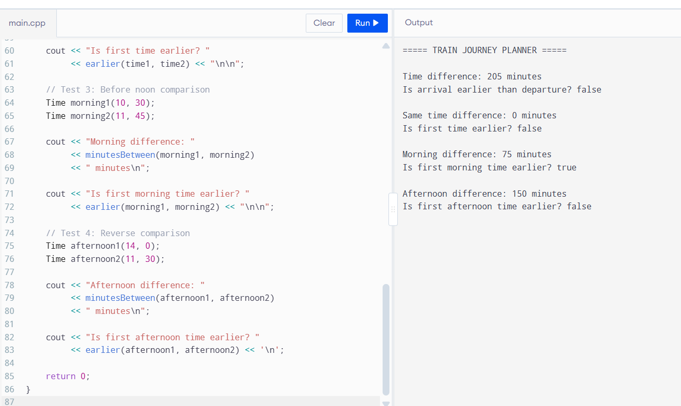
7. Correctness Testing
The program should also be tested with the following cases:
Test | First Time | Second Time | Expected Difference | Expected Earlier Result
1 | 09:45 | 13:10 | 205 minutes | false
2 | 10:00 | 10:00 | 0 minutes | false
3 | 11:30 | 14:00 | 150 minutes | true
4 | 14:00 | 11:30 | 150 minutes | false
5 | 11:50 | 12:10 | 20 minutes | true

These tests verify normal time differences, equal times and comparisons on either side of noon.
8. What Does Inline Actually Mean?
The inline keyword suggests to the compiler that the function's code may be expanded at the calling location instead of using a normal function call.
Possible advantages:
- May reduce function-call overhead for small functions.
- Can be useful when small functions are called frequently.
- Does not change the time complexity of the operation.
However, inline does not guarantee that the compiler will expand the function. The compiler decides whether to inline it based on its optimization strategy.
9. Growth Investigation – Measuring 10,000,000 Calls
The assignment requires comparing execution time for 10,000,000 calls with and without inline functions using -O0 and -O2.
The following program provides a simple benchmark.
#include <iostream>
#include <chrono>
using namespace std;
using namespace chrono;
inline int inlineAdd(int a, int b) {
return a + b;
}
int normalAdd(int a, int b) {
return a + b;
}
int main() {
const int N = 10000000;
volatile long long result = 0;
auto start1 = high_resolution_clock::now();
for (int i = 0; i < N; i++) {
result = result + inlineAdd(i, 2);
}
auto end1 = high_resolution_clock::now();
auto start2 = high_resolution_clock::now();
for (int i = 0; i < N; i++) {
result = result + normalAdd(i, 2);
}
auto end2 = high_resolution_clock::now();
auto inlineTime =
duration_cast<milliseconds>(end1 - start1).count();
auto normalTime =
duration_cast<milliseconds>(end2 - start2).count();
cout << "Inline function time: "
<< inlineTime << " ms\n";
cout << "Normal function time: "
<< normalTime << " ms\n";
cout << "Result: " << result << '\n';
return 0;
}
Note: This is a simple practical benchmark. The volatile result discourages the compiler from removing the accumulated result, but compiler optimization can still affect the generated code. For a more rigorous experiment, inspect the generated assembly and repeat measurements.
Compilation Commands
For no optimization:
g++ -std=c++17 -O0 benchmark.cpp -o benchmark_O0
For optimization:
g++ -std=c++17 -O2 benchmark.cpp -o benchmark_O2
Run both programs and record the actual time displayed.
Optimization | Inline Function Time | Normal Function Time
-O0 | Record actual result | Record actual result
-O2 | Record actual result | Record actual result
The compiler may produce different timings at different optimization levels. At -O2, it may inline even a function that is not explicitly marked inline. Therefore, the inline keyword alone does not guarantee faster execution.
10. Alternative Concept – Member Functions and Getters
Instead of friend functions, the same operations can be implemented using public getter functions and ordinary member functions.
Example:
class Time {
private:
int h, m;
public:
Time(int hh, int mm) : h(hh), m(mm) {}
int getHour() const {
return h;
}
int getMinute() const {
return m;
}
int minutesTo(const Time& other) const {
int first = h * 60 + m;
int second = other.h * 60 + other.m;
return abs(first - second);
}
bool isEarlier(const Time& other) const {
if (h != other.h)
return h < other.h;
return m < other.m;
}
};
Calling the functions:
Time departure(9, 45);
Time arrival(13, 10);
cout << departure.minutesTo(arrival) << '\n';
cout << boolalpha << arrival.isEarlier(departure) << '\n';
Complexity Comparison
Design | Time per Comparison | Extra Space
Friend functions | O(1) | O(1)
Member functions | O(1) | O(1)
Public getters | O(1) | O(1)
All three approaches perform a constant number of operations for each time comparison. Their time complexity is O(1).
Member functions and getters provide controlled access to private data. Friend functions are useful when an operation needs equal access to two objects.
11. Deployment Decision
For the train journey planner, I would retain the friend functions because comparing two Time objects is an operation involving both objects equally.
The private data members remain protected, and the friend functions can perform the required calculations without making the data public.
Inline may be considered for small functions, but actual performance should be verified using compiler measurements at -O0 and -O2.
Conclusion
Friend functions allow non-member functions to access private class members when required. Inline functions may reduce function-call overhead, but the compiler decides whether to inline them. The Time class correctly calculates the difference between two times and compares their order. The design maintains encapsulation and provides efficient constant-time operations.

DAY-4 DESIGN CHALLENGE
Q7 – Diagnose, Redesign and Validate 13 Marks
Bloom’s Level: K5 – Evaluate
Review the evidence you generated while working on Q1–Q6. Select ONE program that shows a significant limitation as the data grows or the requirement changes.
You are not permitted simply to replace your code with a library facility and claim it is better. You must understand the problem first and then develop an appropriate redesign.
A. Diagnose the Limitation – 2 Marks
Using your own evidence, identify where the design fails or slows down and which characteristic of the original design causes it.
Evidence Expected
A precise diagnosis supported by evidence from your original program. B. Define the Design Objective – 2 Marks
State a measurable objective for the redesign.
Evidence Expected
A clearly stated objective derived from the identified limitation.
C. Design the Revised Solution – 4 Marks
Explain what you have changed in the class or function design, which C++ feature you use, whether extra memory is needed, and any new trade-off. Provide a class diagram or pseudocode.
Evidence Expected
A coherent redesign directly addressing the diagnosed limitation.
D. Predict Before Implementing – 1 Mark
Predict the improvement and the measure in which you expect it.
Evidence Expected
A clear, testable prediction.
E. Implement and Validate the Redesign – 2 Marks
Compare Original → Redesigned using the same tests and measurements. Evidence Expected
Comparable evidence for both versions.
F. Defend the Final Design – 2 Marks
Evaluate whether the objective was achieved, new costs, and where the original may still be preferable. A redesign that does not outperform the original is not automatically unsuccessful if you correctly explain why.
Evidence Expected
A critical, evidence-based evaluation and a defensible conclusion.
ANSWER:
Selected Program: Q4 – Savings Account Mini-Statement
A. Diagnose the Limitation
The original SavingsAccount program uses a fixed array of 10 elements to store recent transactions.
When the array becomes full and a new transaction arrives, the program shifts the existing nine transactions one position to the left and stores the new transaction at the last position.
This approach works correctly, but it becomes inefficient when the number of stored transactions increases.
Identified limitations:
- Adding a new transaction when the array is full requires shifting existing elements.
- Increasing the transaction capacity from 10 to 50 increases the number of elements that must be shifted.
- Repeated shifting creates unnecessary data movement.
- The program requires additional logic to maintain the order of transactions.
The original shifting approach requires O(k) time for inserting a transaction when full, where k is the transaction capacity.
B. Define the Design Objective
The objective is to redesign the transaction storage system using a circular buffer.
The redesigned system should:
- Store the latest 10 transactions.
- Automatically remove the oldest transaction when a new transaction arrives after the buffer becomes full.
- Avoid shifting existing transaction elements.
- Display transactions in chronological order.
- Maintain the same deposit and withdrawal functionality.
Measurable objective: Reduce the transaction insertion operation from O(k) to O(1) when the buffer is full, while maintaining the same transaction history.
C. Design the Revised Solution
The redesigned system uses a circular buffer with three important variables:
- transactions[10] – Stores transaction amounts.
- start – Identifies the oldest transaction.
- count – Stores the number of valid transactions.
When a new transaction arrives:
- Calculate the position where the new transaction must be stored.
- Insert the transaction into that position.
- If the buffer is not full, increase the transaction count.
- If the buffer is full, advance the starting index so that the oldest transaction is replaced.
Circular buffer logic:
position = (start + count) % CAPACITY;
When the buffer is full:
transactions[start] = amount;
start = (start + 1) % CAPACITY;
Revised class design:
SavingsAccount
------------------------
accountNumber
balance
transactions[10]
start
count
------------------------
deposit()
withdraw()
addTransaction()
miniStatement()
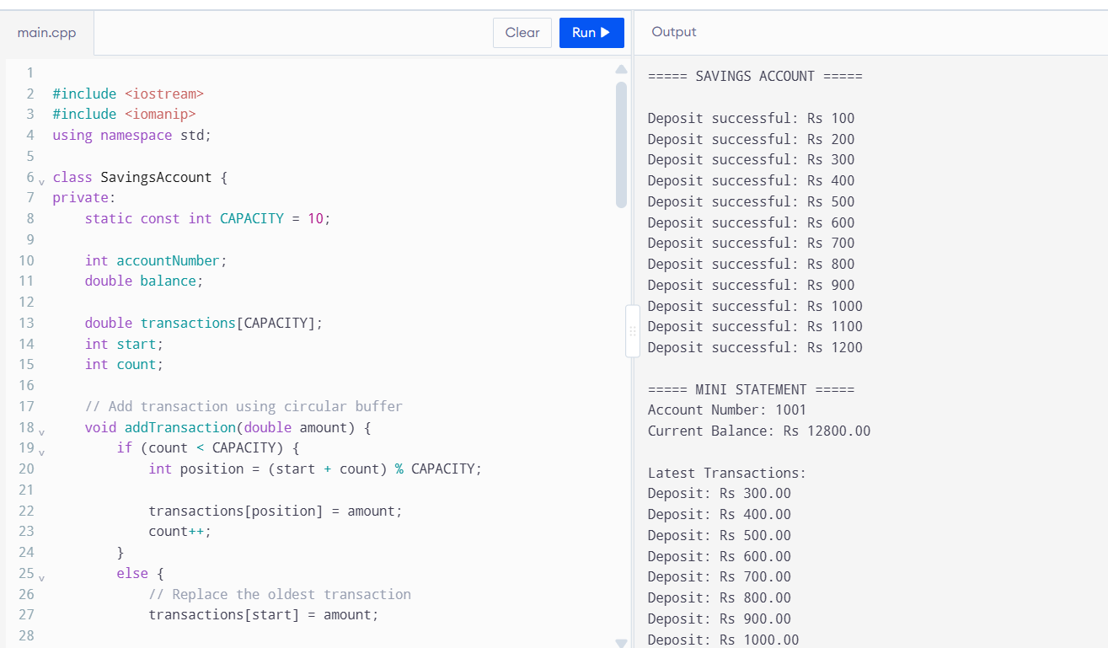
The redesigned class continues to use private data members and public member functions. Therefore, encapsulation is maintained.
Additional memory: The circular buffer uses a fixed array of 10 transaction values and two integer variables (start and count). It requires O(k) storage, where k is the transaction capacity.
D. Predict Before Implementing
Before implementing the redesigned solution, I predict that:
- Every new transaction will be inserted in O(1) time.
- No shifting of existing transactions will be required.
- The buffer will always retain the latest 10 transactions.
- The mini-statement will display the transactions in chronological order.
- The additional memory requirement will remain O(k).
For a full buffer, the redesigned version should perform fewer data movements than the original shifting approach.
E. Implement and Validate the Redesign
Both the original and redesigned programs should be tested using the same transaction sequence.
Test example:
Assume the transaction capacity is 10 and the following 12 transactions are added:
Transaction | Amount
T1 | ₹100
T2 | ₹200
T3 | ₹300
T4 | ₹400
T5 | ₹500
T6 | ₹600
T7 | ₹700
T8 | ₹800
T9 | ₹900
T10 | ₹1000
T11 | ₹1100
T12 | ₹1200
After adding all 12 transactions, both implementations should retain:
Stored Position | Transaction
1 | T3 – ₹300
2 | T4 – ₹400
3 | T5 – ₹500
4 | T6 – ₹600
5 | T7 – ₹700
6 | T8 – ₹800
7 | T9 – ₹900
8 | T10 – ₹1000
9 | T11 – ₹1100
10 | T12 – ₹1200
Expected validation results:
- Both versions should store the latest 10 transactions.
- Both versions should display the same transaction history.
- The original version shifts elements when full.
- The redesigned version overwrites the oldest element using a circular index.
Evidence to collect:
- Screenshot of the original program output.
- Screenshot of the redesigned program output.
- Compiler and version information.
- Actual execution timings, if measured.
- Confirmation that both programs display the same latest 10 transactions.
No execution timing is assumed here. Actual measurements must be collected by running both programs.
F. Defend the Final Design
The circular buffer is a better design when the system frequently receives new transactions and needs to maintain a fixed-size history.
Advantages:
- Insertion takes O(1) time.
- Existing transactions do not need to be shifted.
- The latest transactions are maintained automatically.
- The design uses a fixed amount of memory.
- It is suitable for frequent transaction updates.
Limitations:
- Circular indexing requires additional logic.
- The program must correctly maintain the starting index and transaction count.
- Accessing transactions in chronological order requires calculating their actual array positions.
The original shifting design is still suitable for a very small transaction history or when implementation simplicity is more important than insertion efficiency.
Conclusion
The original SavingsAccount design uses an array-shifting method that requires O(k) time to insert a transaction when the array is full. The redesigned circular buffer reduces this operation to O(1) by replacing the oldest transaction directly. Both designs use O(k) storage and can produce the same transaction history. Therefore, the circular buffer is a more efficient design for a bank system that frequently records transactions.
Submission Requirements
GitHub repository link (mandatory) containing the executed code for every task, including every completed “Complete the Code” program, with input files, output screenshots and a README.md.
• Your assignment report containing the required evidence for Q1–Q7 • C++ source code for all programs
• Predictions, outputs, timings and compiler messages used as evidence
Assessment Verification
Students may be asked to explain any part of their predictions, code, tests or results during a brief verification discussion/viva.

